Innovative Stormwater Management Project Funded
By US EPA Moves Forward

The Lake Hopatcong Commission has been working on projects funded through the Targeted Watersheds Grant (TWG) awarded by the United States Environmental Protection Agency (US EPA). Each project will vary in size and scope, but all the TWG projects will reduce the pollutants running into Lake Hopatcong.
Staff from the Lake Hopatcong Commission and the Borough of Hopatcong Department of Public Works (DPW) recently began work on a small-scale retrofit project to install grate inlet skimmer boxes containing iron oxide sleeves in catch basins near Ingram Cove in Lake Hopatcong.
This innovative project was identified because a substantial portion of the near-shore land within the Lake Hopatcong watershed is residential land and some areas of the watershed are at or near build-out conditions. Under these conditions, there is little or no available space for the installation of larger stormwater management projects such as wetlands/wet ponds or sub-surface sand filters.
The Commission and Hopatcong DPW staff selected a set of four existing catch basins for this project. The catch basins were sized for the design and installation of grate inlet skimmer boxes used primarily to collect trash and suspended solids. Two of these four small-scale retrofits were modified to house a "sleeve" of iron oxide to enhance the removal of the stormwater-based phosphorus, particularly dissolved forms. In the presence of oxygen, iron strongly binds with phosphorus, making it unavailable for algal and aquatic plant growth. The Commission will compare the retrofits that do not have iron oxide sleeves to those that do and document the increased removal rates of phosphorus.

In order to determine the effectiveness of the iron oxide sleeve, the Commission staff will collect water samples after rainstorms to assess the phosphorus removal capacity of these retrofit. This slight modification to an existing catch basin could be an extremely cost-effective means of enhancing phosphorus removal rates within the Lake Hopatcong watershed.

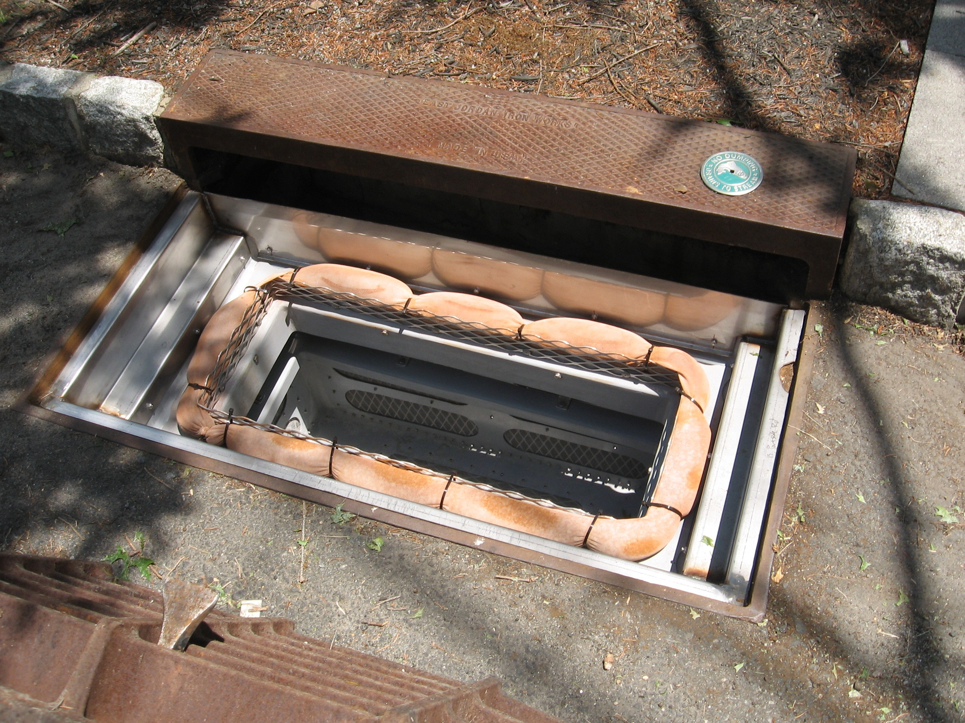 | Iron/Oxide Sleeve installed in catch basin on Portside Road near Ingram Cove in Hopatcong Borough. Iron strongly binds with phosphorous which should reduce phosphorus entering Lake Hopatcong.
LHC and Hopatcong DPW staff finishing up installation. | 