LAKE HOPATCONG PUMP OUT STATIONS

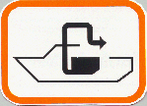

Barnes Bros. Marine  11 Windmere Ave., Mt. Arlington  973-398-0751  Near Mount Arlington Public Beach  (Open for public use weekdays only) | Johnny’s Marina  453 Riverstyx Rd., Hopatcong  973-398-8500  Near River Styx Bridge
Flash Watersports and Marina  155 Rt 181, Lk Hopatcong  973-663-7990  Woodport Cove | Katz’s Marina at the Cove  22 Stonehenge Rd., Lk Hopatcong  973-663-0024  Great Cove (Lake access only)
Contact marinas directly for pump out rates and hours of operations.

HELP PROTECT LAKE HOPATCONG
PUMP IT! DON’T DUMP IT!
Learn more on how to protect Lake Hopatcong at www.lakehopatcong.org
Lake Hopatcong Commission  P.O. Box 8515  Landing, NJ 07850  973-601-1070
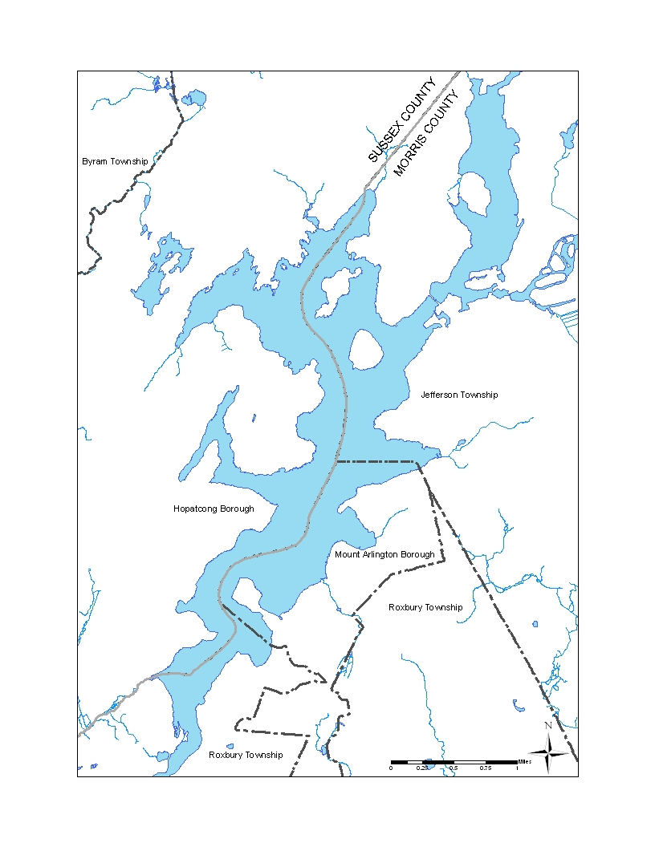
Barnes Bros. Marina
(Near Mt. Arlington Public Beach)
973-398-0751
Flash Marina
(Woodport Bay)
973-663-7990
Royal Wave Marina
(Great Cove)
973-663-0024

LAKE HOPATCONG PUMP-OUT STATIONS
Johnny’s Marina
(Near River Styx Bridge)
973-398-8500

